**PROPOSAL REPORT WRITING PLANNER  
FINAL REPORT**

**CCBC 7 - Nam and Henry**

TCOM-600-003 Business Technology Communications

Instructor: **Susan Burton, MSc, MA**

2023/2024 Fall Semester

Saskatchewan Polytechnic

Submitted:

**November 02, 2023**

Table of Contents

I. Pioneering Purolator's Cloud Migration for Financial Excellence 1

1. Company background 1

2. Company needs 1

II. Why Public Cloud 2

1. Cost Reduction 2

2. Enhance Operational Efficiency 2

III. Benefits of Public Cloud 2

1. Expense 3

2. Scalability 4

3. Accessibility 5

IV. Potential Concerns & Solutions of Public Cloud 5

1. Compliance 5

2. Data Security 6

3. Integration Complexities 6

V. Other alternatives 6

1. Hybrid Cloud 6

2. Private Cloud 7

VI. Conclusion & Recommendation 7

1. Comprehensive Assessment 7

2. Action for Data Security 7

3. Gradual Migration 8

4. Training and Changing Management 8

# Pioneering Purolator's Cloud Migration for Financial Excellence

In today's fast-evolving business landscape, harnessing efficient technology solutions is the cornerstone of sustained success. This internal proposal is designed to provide a comprehensive plan for Purolator's transition from on-premises IT infrastructure to cloud-based solutions, with a focus on optimizing capital expenditure through Cloud Migration.

## Company background

Purolator is a leading freight, package, and logistics provider, serving Canada and the U.S. Our vast network encompasses facilities, courier vehicles, and authorized agents, facilitating the daily delivery of over a million packages. Our workforce of 14,000 employees powers our operations. We navigate a dynamic marketplace, recognizing the need for adaptability to maintain our competitive edge. Our commitment extends to cross-border shipping and environmental initiatives, solidifying our reputation in the industry. Embracing cutting-edge technology and innovative solutions remains pivotal to our prominence in the logistics and transportation sector.

## Company needs

This proposal is presented in response to the directive from our Chief Technology Officer (CTO) and serves as a formal recommendation to the Board of Directors and Senior Management. It outlines a strategic path for Purolator's migration from on-premises IT infrastructure to cloud-based solutions. This transformation is poised to optimize capital expenditure, through Cloud Migration, and ensure our technology strategies remain agile in response to the evolving demands placed on our organization.

# Why Public Cloud

Our motivation to transition to the public cloud is driven by a profound need to embrace a cost-effective, agile, and innovation-focused technological landscape. This section delves into the core reasons behind this strategic shift, emphasizing its critical advantages.

## Cost Reduction

Our primary driver for migrating to the public cloud is substantial cost reduction. This transition shifts our financial model from capital expenditures to a more cost-efficient operating expense structure. By eliminating the need for substantial upfront investments in on-premises infrastructure, we can streamline operations and allocate resources more effectively. The result is a more cost-effective and flexible IT landscape, allowing us to redirect funds towards strategic initiatives, fostering innovation and growth.

## Enhance Operational Efficiency

Our transition to the public cloud aims to optimize operational efficiency. Managing on-premises servers, forecasting capacity needs, and infrastructure maintenance will become obsolete. This transition allows us to allocate our resources toward strategic development and innovation, fostering agility and efficiency. Cloud migration empowers our IT teams to focus on high-impact projects, improving customer experiences and maintaining a competitive edge. This pivotal shift will help us harness emerging opportunities in the dynamic business landscape.

# Benefits of Public Cloud

Cloud computing offers several advantages, particularly in the public cloud domain that we mentioned above. There are three key points we would like to mention: Expense, Scalability,

and Accessibility. For each benefit, we will use real numbers from the company's expenses for IT infrastructure.

## Expense

The main factor that necessitates this proposal is expenses. This could save capital expenses for the company, as described in the paragraph below:

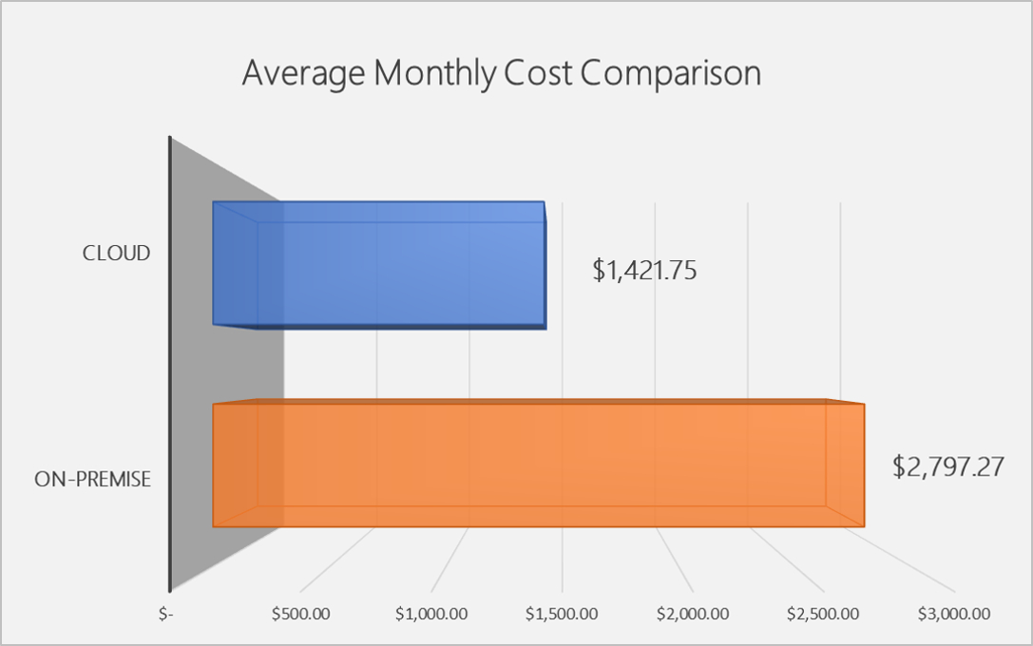

The current on-premises IT infrastructure costs us $2,797.27 monthly, and we had to invest approximately $30,000 initially for servers, data centers, and miscellaneous expenses. When it comes to Cloud Services, we only need to pay $1,421.75 without any initial costs. Cloud computing will reduce expenses by up to $1,375.52 every month, almost 50% of the current costs.

## Scalability

The other aspect we must mention here is the scalability of Amazon Web Services, the provider that offers the public cloud computing we are proposing. The images below describe how it works, and we can scale up and scale down the infrastructure easily:

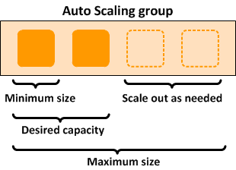

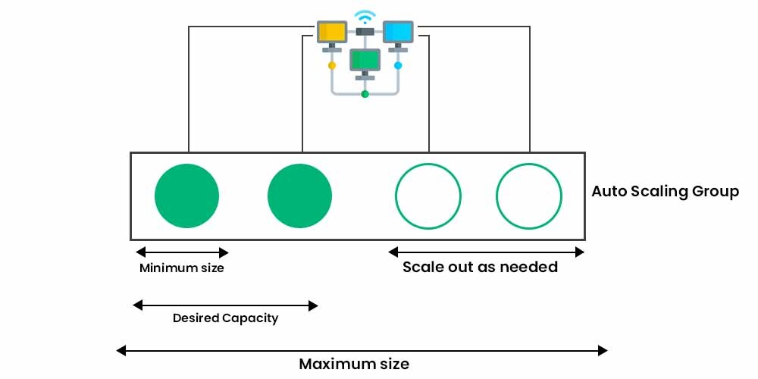

This shows that money could be saved by the AWS models in the long run without any additional charges. Moreover, the IT department could work more efficiently, instead of guessing how many servers we need in the first place.

## Accessibility

Accessibility is a vital factor we must consider when moving to cloud computing. Our IT department was locked down during Covid-19 and could not access the servers in data centers for a month. Despite many efforts to connect to the main server, we were unable to fix it in person. With this in mind, we include this information in the proposal to inform you about how cloud computing could solve the problems that occurred in the past and could potentially happen in the future.

Cloud computing enables us to access the entire services remotely, with a commitment of up to 99.99% uptime from AWS. In addition, the Enterprise Support plan can assist us in fixing issues as quickly as possible, 24/7, when we make a request via a hotline that is set up exclusively for our company.

# Potential Concerns & Solutions of Public Cloud

The benefits of cloud computing could outweigh the concerns, but we still want to mention them here to ensure transparency in this proposal.

## Compliance

First and foremost, compliance with government regulations is a significant consideration. For instance, there are certain acts that require us to store users’ data on a server using on-premises services. This is mandatory for some industries such as healthcare, insurance, or banking. We might not have to worry about this issue for three reasons:

* We are not on the list of companies mandated to ensure data security.
* We will use cloud computing services in the Canada region.
* We will adhere to all rules that might change in the future.

Currently, we are in a good position, but circumstances could change, and we must be prepared to adapt.

## Data Security

There are some concerns about the security of cloud computing and its data protection rules. No audit companies could confirm Amazon Web Services' data protection, but one point worth noting is that the Government of Saskatchewan uses Amazon Web Services for their databases.

More importantly, Amazon employs top engineers from around the world to protect all their services. If we were to protect our data on an on-premises server compared to them, it would require significant efforts and resources. Therefore, instead of relying on an in-house security team, we propose using Amazon's top-notch services.

## Integration Complexities

Cloud computing is a recent and rapidly growing technology. We must learn about it and find a way to migrate our IT infrastructures from on-premises to the cloud. The demand for cloud engineering expertise is widespread globally. Therefore, we suggest that in-house training could benefit us more than hiring or outsourcing this expertise.

# Other alternatives

After numerous meetings, we may have dismissed two other alternatives that could benefit us similarly to cloud computing.

## Hybrid Cloud

Hybrid Cloud is a service where we use some parts on cloud computing and some on-premises, which leads to another problem: we have to separate resources for the same purpose. We initially refused to use this due to the need for capital expenses and the fact that it doesn't completely enhance our IT.

## Private Cloud

After discussing with Amazon Web Services experts, we had to remove this option from the table due to its cost, which is even higher than that of an on-premises solution. With this, we not only pay for the cloud computing services but also have to cover the salary of a team of AWS professionals to help us operate the private cloud.

We might have to reconsider these options in the future when the yearly budget of the IT department increases, or if our team cannot handle the learning curve and integration complexities mentioned above.

# Conclusion & Recommendation

This proposal demonstrates the needs of our company and the benefits that could help us save more expenses. There are four factors we need to clarify in this section.

## Comprehensive Assessment

We recommend a thorough evaluation of our current IT infrastructure to identify which components are best suited for migration to the public cloud. This assessment will ensure an efficient transition that aligns with our business objectives.

## Action for Data Security

To address data security concerns, we propose engaging Amazon Web Services' top-tier security experts. Their expertise will fortify our cloud infrastructure, protecting sensitive data and ensuring compliance with evolving regulations.

## Gradual Migration

We advocate a phased approach, commencing with non-essential systems to minimize disruptions. This gradual migration strategy allows for testing, fine-tuning, and a smoother transition, ultimately enhancing operational continuity.

## Training and Changing Management

Adequate training for our teams is pivotal. We propose comprehensive in-house training to equip our staff with the necessary skills for managing cloud resources effectively. Change management initiatives will facilitate a seamless shift to a cloud-centric environment.

We kindly request the endorsement of our Board of Directors and Senior Management for this strategic move. This proposal reflects our unwavering commitment to ensuring the excellence of Purolator's services in an ever-evolving marketplace.